To informality and beyond:
A gender analysis of informal labour and precarious working conditions.

Online Appendix: Tables and Figures

Table 1.2 – Descriptive statistics of dependent variables
Notes on Table 1.2:
- Being an informal worker: In Mexico, labour informality is measured based on social security registration. Wage employees are classified as informal if their employer does not register them with the IMSS. The self-employed are considered formal only if they pay their own pension contributions and have access to medical coverage. Ultimately, INEGI includes a variable in the ENOE that indicates whether the individuals are considered formal or informal workers based on these criteria.
- Being a subordinate worker without a contract: This variable omits employers, the self-employed and unpaid workers, since these types of jobs do not involve contracts. INEGI includes this variable in the ENOE survey to analyse only those who are employed by someone else and to identify whether they have a contract or not.
- Being paid on a daily basis: Almost 25% of workers who reported having a job did not provide information on their payment frequency. These cases are kept as missing values in this variable.
- Earning less than the minimum wage: The ENOE survey includes a question that informs respondents of the current monthly minimum wage in Mexico and then asks whether they earn more or less than the minimum wage. Nevertheless, many individuals report earning less than the minimum wage, not because they are being underpaid, but because they worked fewer than the standard 48 hours. Estimating the probability of earning less than the minimum wage without considering hours worked would lead to misleading results. INEGI includes a variable identifying individuals who earn less than the minimum wage despite working more than 48 hours. This is the variable employed in the regression analysis.

Table 1.3 – Descriptive statistics of variables capturing individual and household characteristics

Table 1.4 – Descriptive statistics: year, quarter and Mexican states

Table 1.5 – Descriptive statistics of the variable capturing 50 economic activities

Notes on Table 1.5:
- The descriptive statistics are based on the whole sample, which includes four different years.
- Informality rates and the share of women in each activity were estimated using the 2019 dataset exclusively.
- Economic activities starting with M refer to manufacturing activities.
- Economic activities starting with R refer to retail services.
- INEGI establishes reliability thresholds indicating the degree of statistical precision based on the coefficient of variation of the estimates.
- A coefficient of variation greater than 30% indicates low reliability, and it requires cautious interpretation, including an analysis of the causes of the high variability and the consideration of alternative precision measures such as confidence intervals (INEGI, 2021a).
- A threshold between 15% and 30% indicates moderate reliability (INEGI, 2021a).
- A coefficient of variation below 15% denotes high reliability (INEGI, 2021a).
- The coefficient of variation for all economic activities is below 15%, which implies that the estimates at this level of disaggregation are highly reliable.
- The estimation of the coefficient of variation for each economic activity explicitly incorporates ENOE’s survey design, which considers the primary sampling units, sampling weights and stratification structure.
- The reported statistics appropriately reflect the underlying sample design rather than assuming simple random sampling.
- The ENOE survey is designed to be representative at the national level, across the 32 federal states, and between urban and rural areas of Mexico.

Table 1.6 - Descriptive statistics of the variable ‘NAICS: Economic activities’

Notes on Table 1.6:
- The economic activity 8121 ‘Personal services’ required further disaggregation.
- Hairdressing, grooming, and make-up services accounted for 6,563 of the 10,490 observations in the economic activity 8121 ‘Personal services’.
- The remaining observations of economic activity 8121 were classified under category 51, ‘Other Economic Activities’.
- Economic activity 4611 is associated with grocery stores that are commonly known in Mexico as ‘corner stores’ and are typically operated by the owner of the store.
- Economic activity 4620 refers to convenience stores such as 7-Eleven and Oxxo. In this case, the owners of the convenience stores hire employees to operate their business.
- Bachas et al. (2020) also makes a distinction between two types of stores in Mexico, the ‘traditional’ Mexican convenience store in the informal sector and the ‘modern’ convenience store in the formal sector, such as 7-Eleven or Oxxo.
- Economic activities starting with M indicate manufacturing activity.
- Economic activities starting with R indicate retail trade activity.

Table 1.7 - Proportion of workers experiencing different precarious working conditions
across 50 economic activities in Mexico
Notes:
The statistics show the proportion of workers in each economic activity who are experiencing a specific dimension of labour precarity, relative to the total number of people working in that activity.

Table 1.8 – Informal employment rates in Mexico by gender (2019 and 2024)
Source: INEGI statistics from the ENOE household survey

Table 1.9 – Gender composition of the informal and the formal workforce in Mexico (2019)

Source: INEGI statistics from the ENOE household survey

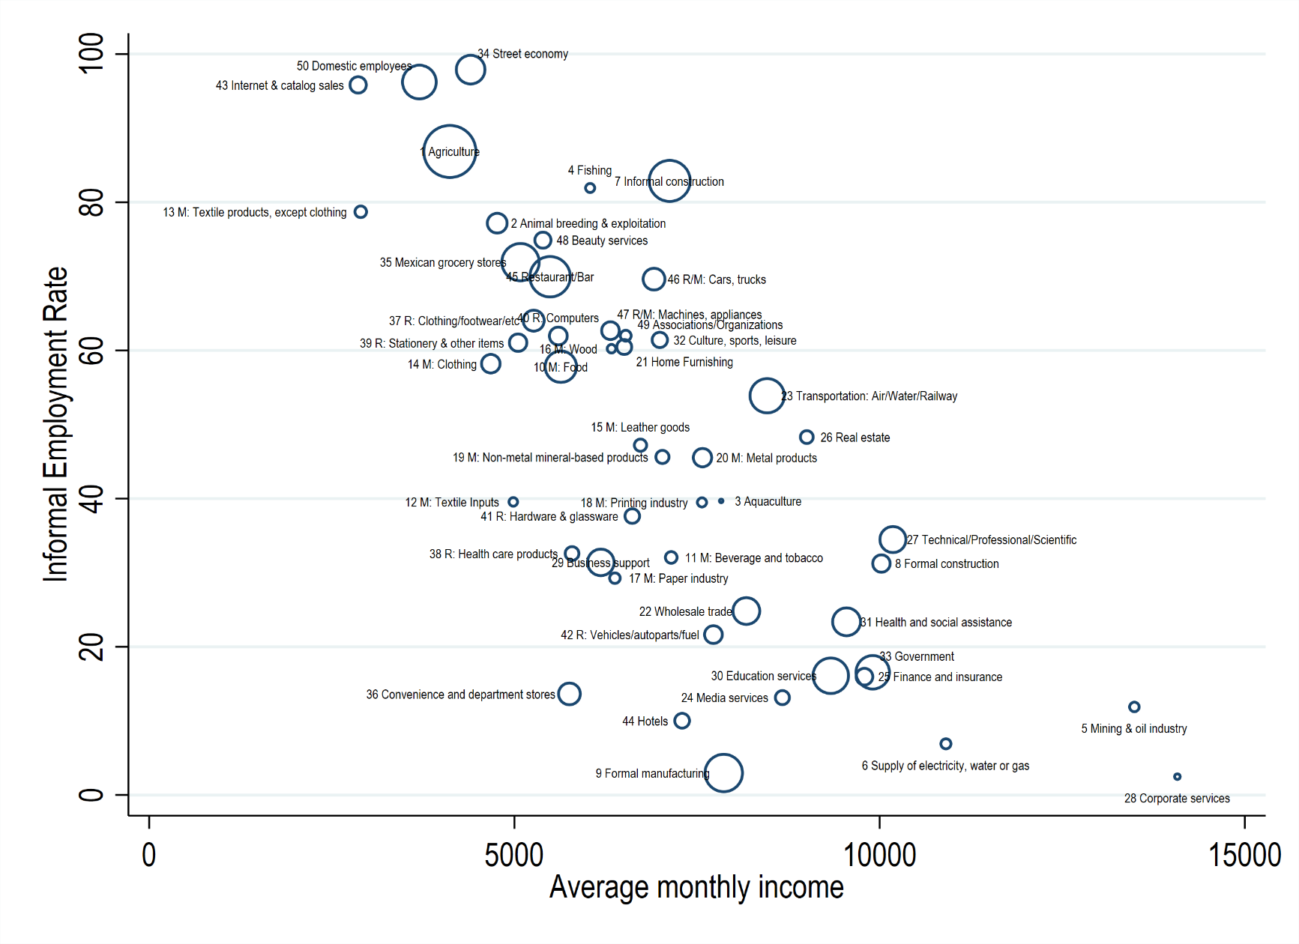
Figure 1.4 - Informal employment rates and average monthly labour incomes across 50 economic activities.

Notes:
- The size of the dots reflects the proportion of people employed in each economic activity.
- These 50 economic activities account for 98% of the total labour force in Mexico.
- Economic activities starting with ‘M:’ are manufacturing activities.
- Economic activities starting with ‘R:’ are retail services.
- The estimates of informal employment rates and the share of women and men in each economic activity fall within the variation coefficients established by INEGI, based on the sampling design of the ENOE household survey, as shown in Table .
- A detailed explanation of how each of the 50 economic activities was categorised can be found in Table .

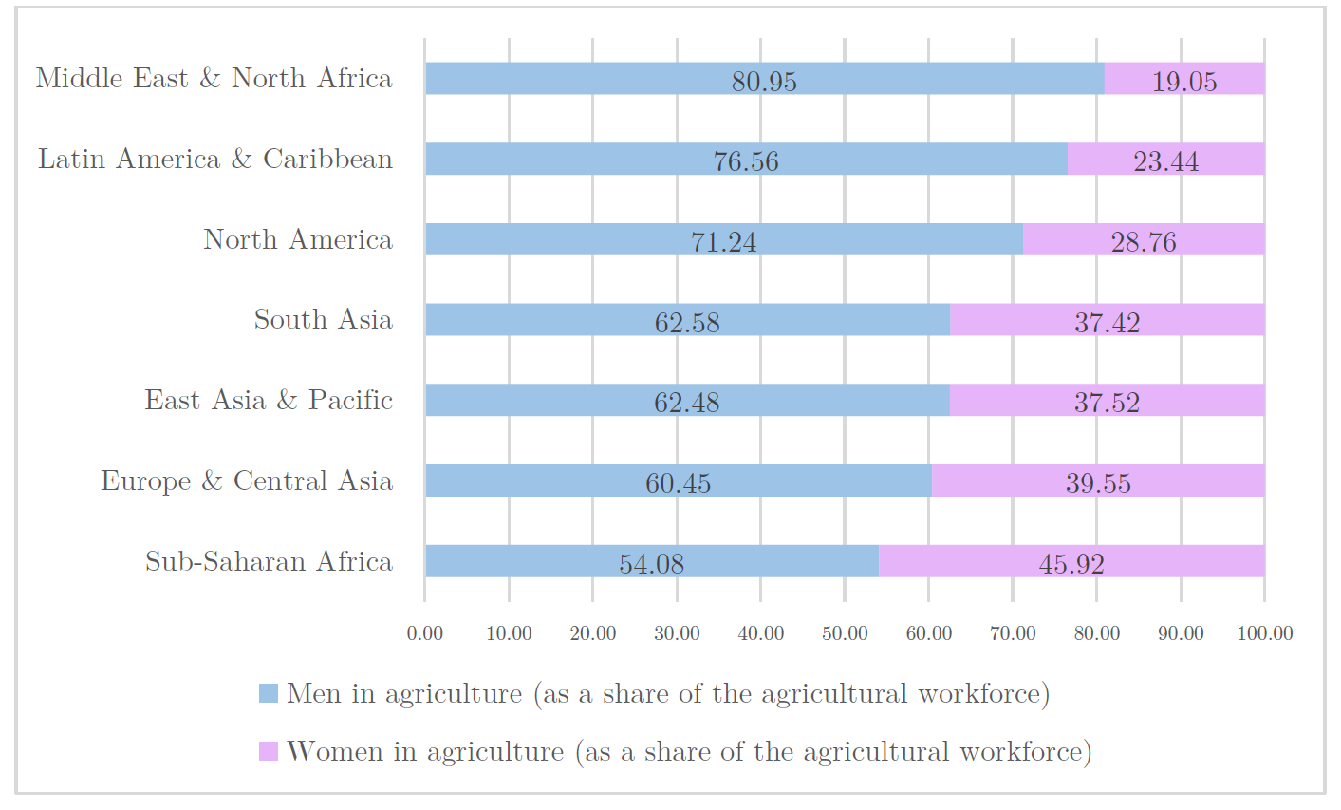
Figure 1.5 – Composition of the agricultural workforce by sex and region (2022)

Notes:
- Made by the author using data from the World Bank.
- The figure illustrates that men represent the predominant share of the agricultural workforce in all regions of the world, based on the classification of areas established by the World Bank.
- This is in line with Doss & Gottlieb (2025)who find that, in their sample of 85 countries, men represent more than half of those employed in agriculture in the majority of countries.

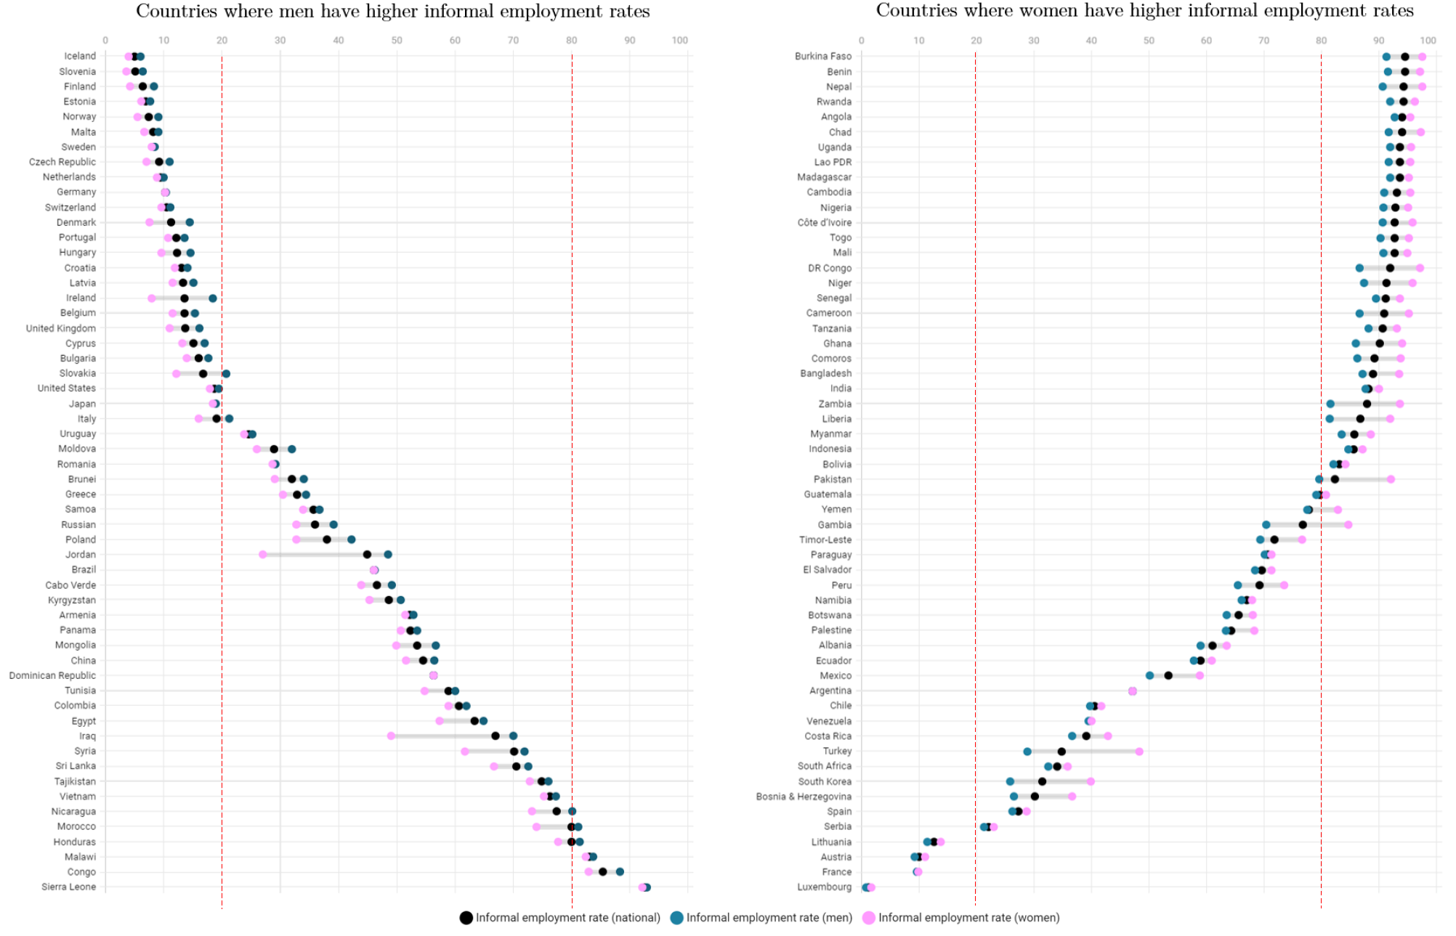
Figure 1.6 – The reversal of gender gaps in informal employment rates across countries

Notes:
- This figure covers 112 countries, with estimates of informal employment rates that include, for the first time, agriculture alongside industry and services.
- The left-hand side of the figure shows that in 56 countries, ranging from Iceland to Sierra Leone, men report higher informal employment rates than women.
- The right-hand side of the figure shows that in 56 countries, from Burkina Faso to Luxembourg, women exhibit higher informal employment rates than men.
- The figure suggests that, once agriculture is considered, women do not exhibit higher informal employment rates across countries.
- ILO (2018) reports that the estimates were obtained after harmonising household surveys conducted by each country, using data from different years (mostly 2010–2016).
- ILO (2018) indicates that its estimates of informal employment rates cover 119 countries. They also note that the statistics for seven countries were obtained from ILOSTAT, but the estimates of informal employment rates for these seven countries do not appear in their Appendix. Hence, this analysis relies on the estimates for 112 countries.
- Another interesting trend in this figure is that most countries with low informal employment rates (20% or less) tend to exhibit higher informal employment rates for men. In contrast, countries with high informal employment rates (80% or more) consistently report higher informal employment rates for women.
- The figure suggests a reversal of gender gaps in informal employment as part of economic development.
- In low-income countries with high informality rates, formal jobs may be reserved for or taken by men, which may explain why women report higher informal employment rates.
- In high-income countries with low informality rates, most women secure formal jobs, while some may prefer not to work rather than take informal jobs. Most men also obtain formal jobs, but those who do not may be more inclined to take informal jobs. This may explain why men report higher informality rates than women in developed countries.
- The World Bank (2022) find a similar pattern. In low-income countries, women are more likely to take the most vulnerable jobs (self-employment and unpaid work in family businesses). Meanwhile, the gender gap flips in high-income countries, as men tend to occupy the most vulnerable jobs in developed economies.
- The interpretations drawn from this figure are illustrative. Other explanations of the phenomenon identified in this research may also be valid. It is beyond the scope of this study to identify the mechanisms driving this cross-country pattern.

